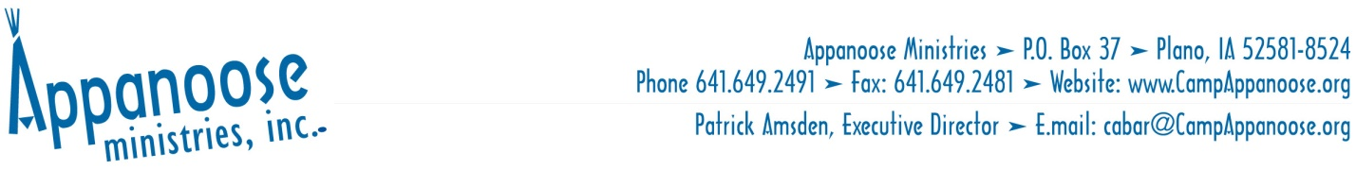
Monthly Newsletter – November 2020
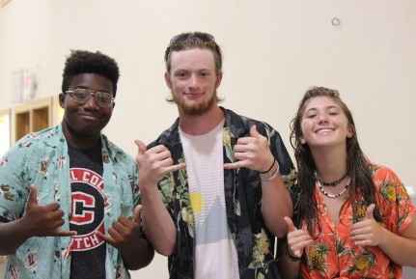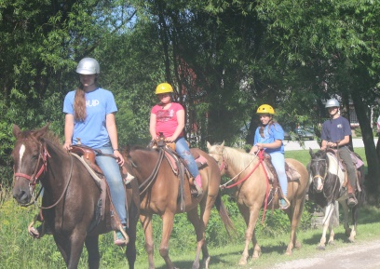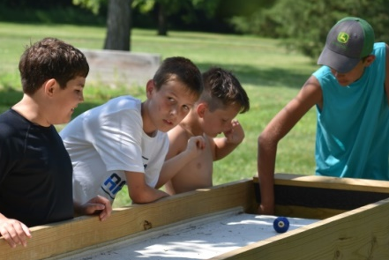
SO MUCH FOR WHICH TO BE THANKFUL!
What a ride 2020 has brought us on this little blue marble! With so many risks has come great opportunity to test out the reality of dependence upon the One we make claim to trust. There is so much for which to be thankful! Beginning to grapple with some big questions a mere ten months ago, few definitive answers emerged, but as is so often the case, our great Leader guided us one step at a time and demonstrated His absolute faithfulness each step of the way.
Thanksgiving emerges over one hundred times in the Old Testament with several high points. One of those would be the Feast of Tabernacles, or Sukkot, celebrated in October and commemorating God’s deliverance from Egypt as well as the blessings of harvest. In the New Testament thankfulness is a universal evidence of the Holy Spirit’s control of one’s life. In contrast, when Paul describes the degraded condition of the gentile world, he says that while, “They knew God they did not honor Him as God or give thanks. Then later in the same passage, he went on to describe the opposite of thankfulness (Romans1:28-32).
Thankfulness is a mindset, or pattern to be developed in life. While it is how we glorify God (the purpose of life) it also supplies several benefits to the thankful. One of the expressed values which Camp Appanoose attempts to instill is that of thankfulness as a pattern of life. Following are several ways in which godly character is nurtured through the habit of thanksgiving:
- Life perspectives are corrected. Psalm 100 is a reminder that, “It is He who has made us, and not we ourselves; we are His people and the sheep of His pasture.” Along with the tendency toward celebrity worship, pervasive in this culture, has emerged a similarly pervasive tendency toward destructive feelings of inadequacy. Not all will enjoy the same accomplishments, the same physical qualities, or athletic or creative talents. The worn out idea that “you can do anything you put your mind to” doesn’t work for many. We have found great value in enabling young people to understand their talents, abilities, physical characteristics, and life circumstances as gifts from a sovereign God who made them for a good purpose. It is He who defines them. It is He who owns them. It is He who defines the boundaries of the pasture, and His objectives are good, even productive. Gaining that perspective encourages thankfulness rather than dissatisfaction.
- Dependency upon God is encouraged. Jesus taught His students to pray, “Give us this day our daily bread,” Matthew 6:11. Thankfulness to God is a continual reminder that He is the source of supply. Not only is He the maker, but the sustainer as well. Several years ago, it occurred to me, that I would rather trust a million dollars in the bank than the God of the universe. Discerned honestly, the desire to trust anything other than His is the fallen urge to be in charge of life, to be free of the boundaries of His pasture, to enjoy the autonomy of making choices apart from accountability. Thankfulness underscores dependency on the sovereign God.

- Humility replaces pride. Solomon wrote, “Only by pride cometh contention” (KJV). Just as the materialistic love of money is the root of all evil, so pride is at the root of human strife,
division, and destruction. While pride leads to conflict, humility leads to peace. A thankful pattern of life is one of humility as God, rather than self, is given the credit for accomplishments, and the glory for results. The absence of pride allows fertile ground in which peace may grow. In James (3:18) we read that, “a harvest of righteousness is sown in peace by those who make peace.”
In this season of Thanksgiving, we remember so many instances of God’s provision as well as His direction in the past year at Camp Appanoose: a wonderful program, eager participants, sensitive staff, a covid free summer, to name a few of the rich blessings of 2020. After several difficult financial years, the Lord enabled us to finally operate in the black financially, often with not much to spare, but with evidence of His provision. Entering the winter months we encourage you, our friends and co-laborers to consider what the Lord may have you to do in supporting this wonderful ministry opportunity for young people.
May you and yours experience this season of gratefulness. Happy Thanksgiving!
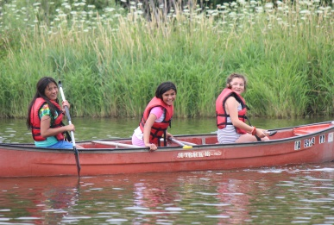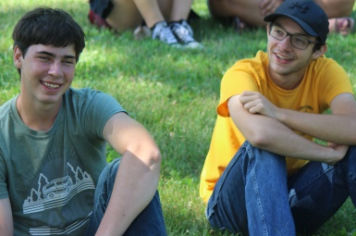

Gifts to this ministry may be sent by US mail or by PayPal at campappanoose.org. *All gifts are tax deductible. *You may be able to give through your employer. Some employers will match your gift. Check with your employer for details.

Unique Camps, Educational Travel, Youth Specialists
www.CampAppanoose.org

